Specialized Project Report 1

*Chelsea Chen, Cait Clancy, David Gonzalez, Sepehr Rostamzadeh*

ME 329 | 8 February 2021

# Problem Definition

Currently, to the extent of our knowledge, there does not exist a single ready-to-use computational model that can output the metabolic energy expenditure for a cyclist given a set of parameters such as saddle height, cadence, posture, anthropometric measurements, and other rider-specific metrics. We will utilize OpenSim, a biomechanics computational tool, to work towards a usable model with saddle position as a primary input and cyclist metabolic energy expenditure as a primary output. Our two progressive goals are thus to be able to measure metabolic data in OpenSim for a simple cycling model. Following those initial iterations, we will add complexity to the cycling model by varying the input parameters in order to establish a more realistic model capable of generating metabolic data for a variety of input parameter values.

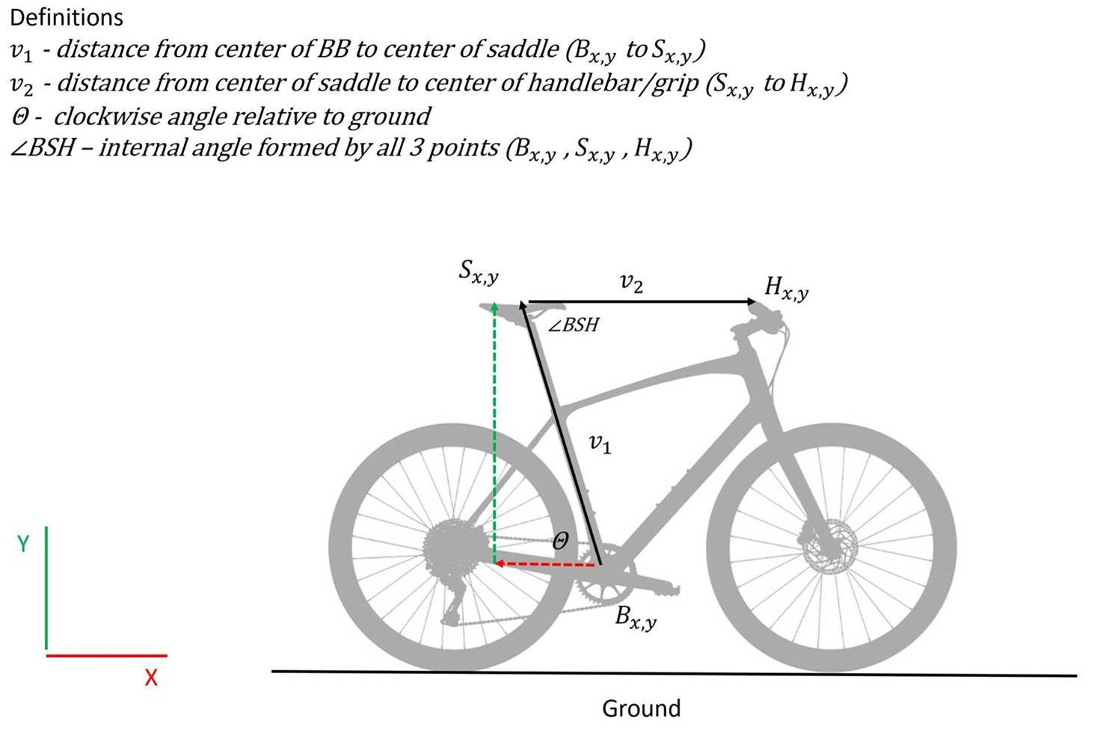  
*Figure 1, Saddle Position, $S_{x,y}$, is defined as the xy-position relative to the bottom bracket of the bicycle. [1]*

Specifically, we will iterate over the xy-coordinates for the pelvis of our model (corresponding to a change in saddle position), the number of utilized muscles in the model, and the external force profile between iterations. After each of these adjustments, we will generate the necessary information in order to use OpenSim to compute metabolic output. We can then quantitatively map out the relationship between cyclist’s energy expenditure (main output) and the saddle position (main input).

# Problem Context

Bicycling, or cycling, is referred to by many as the most efficient mode of transportation [3]. Efficiency is measured as the ratio of mechanical power output to the metabolic cost. Moreover, sustained power is assumed to be a function of metabolic cost [2]. By determining methods to maximize efficiency, cyclists can maximize their cycling performance. To our knowledge, there is no established workflow incorporating computational tools for quantifying the change in metabolic expenditure based on changes in seat positions in cycling. Our goal is to establish a workflow to compute the metabolic expenditure during cycling as a function of saddle (seat) position for our industry partner, Specialized, so that they can incorporate this computational modelling workflow into their design cycle to make design changes geared towards maximizing cyclist efficiency.

OpenSim uses both forward dynamics and inverse dynamics calculation-based solvers to simulate biomechanically accurate motion. Forward dynamics (used by the Forward Dynamics Tool) includes calculations to produce kinematic outputs based on muscle activation inputs. This means the researcher supplies a specific activation value between 0 to 1 for a particular muscle at a specific moment in time for an output of kinematic motion. Inverse dynamics (used by the Computed Muscle Control, CMC Tool) includes calculations for outputs of muscle excitations and activation data based on kinematic inputs. This means the researcher must provide kinematic data and external force data to describe the motion the researchers would like to see generated by some combination of muscle activation. The CMC Tool is a very powerful tool in that it optimizes muscle activation such that the desired kinematic motion that was supplied is achieved. From this, metabolic cost can be calculated. Throughout a cycling revolution, muscles are activated by different amounts at different times and solving for the precise pattern of muscle activations is a task for which OpenSim is particularly well suited.

# Related Work

OpenSim has been extensively used in research and industry as a biomechanics modeling tool to track motion and metabolic efficiency since 2007, when Dr. Scott Delp and his team first released the software to the world. Dr. Delp’s research group at Stanford has published several papers in this realm, mostly from their robust walking models in relation to metabolic consumption. From their paper in 2017, we observed how OpenSim can be used to simulate ideal assistive walking devices with the goal of reducing the metabolic cost for these subjects [5]. The software’s built-in Computed Muscle Control (CMC) Tool, which will prove to be of great importance to our workflow as well, helped solve for muscle excitations in their model based on a prescribed motion (i.e. set of kinematics). This CMC Tool output was then used to estimate metabolic energy consumption. We found that several other Stanford publications related to metabolic efficiency of walking and running also heavily depended on results from the CMC Tool [13][14][15].

Some researchers (outside of Dr. Delp’s group) have published data on OpenSim cycling mechanics that resonate more with our Problem Definition. In 2008, a master's student from Ball State University modified a common two-legged model on OpenSim to represent a cycling motion in order to measure metabolic output as a function of cleat placement on the pedal [7]. Other researchers have shown that changing the hip joint angle (e.g. altered by changing the seat, or saddle, position with respect to the bicycle bottom bracket, or the shaft in which the bike’s cranks mate) has been proven to affect metabolic energy, power, muscle activation, and overall body kinematics [2]. Changes in aerodynamic drag based on seat position has proven to be a significant player in affecting overall cyclist efficiency [2], which is not being considered in the scope of this project but may be added later by Specialized. This is a possible area for additional future investigation. We further identified several other instances of muscle activation and joint angle experiments to add to our collection of cycling subjects [16][17][18]. It is important to note that these data were professionally extracted from a series of empirical trials with expert cyclists, utilizing electromyography to evaluate muscle exertion and motion capture technology to measure joint angles.

Since developing a model in OpenSim from scratch is not within the scope of this 10-week period, we were fortunate enough to acquire a one-legged cycling model from the 2018 ME485 project course (Modeling and Simulation of Human Movement) at Stanford [19]. This group of students developed an educational cycling model for the purposes of getting high school students excited about biomechanics. It is a very simple model, with only four muscles in the upper leg, a fixed foot to pedal constraints, and a fixed pelvis location. The ME485 group was able to generate a set of functioning forward dynamics but it only relies on the activation of two muscles to drive motion. Our team will use and build upon this model as a starting point for reasonable cycling kinematics on OpenSim.

Workflow Testing

In order to determine how saddle position affects cycling energy efficiency, we will use OpenSim’s toolboxes. We have narrowed down our methods to a workflow of tools and strategies to continually expand the scope of our research question and help refine the fidelity with which we answer them.

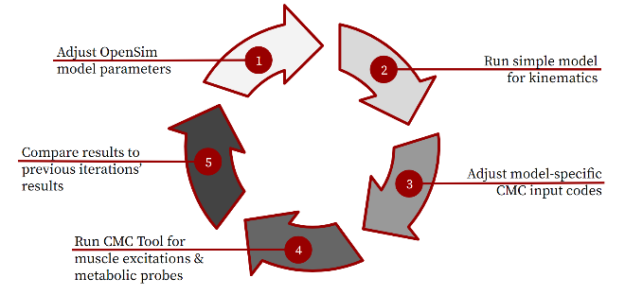

*Figure 2, Analysis workflow using OpenSim to determine metabolic efficiency while cycling.*

Our chosen workflow is as indicated in Figure 2. (1) The first step of the workflow is to adjust the musculoskeletal model and OpenSim start up files to change the saddle position, among other input parameters. (2) The second step is to run the Forward Dynamics Tool on the OpenSim model to obtain joint kinematics. Using a “stripped down” model, where only a skeletal leg is present and no leg musculature is included, we can streamline generating joint angle trajectories. Ground reaction forces, applied at the pedals, will then also be generated using the anthropometric dimensions of the model and the kinematic data. (3) The third step is to adjust model-specific input codes for the Computed Muscle Control (CMC) Tool of the OpenSim model with Metabolic Probes Analysis. (4) The fourth step is to run the CMC Tool to obtain muscle excitation and metabolic probe results using the kinematic motion data and generated ground reaction force data. (5) The fifth and final step of the workflow is to compare the results of the iteration to previous results to determine how the iteration’s saddle height affects cycling metabolic cost and thus efficiency.

Step (1) is where we make specific changes to the OpenSim model in terms of position and selected musculature. This refers to how we plan to iterate over a large space of xy-coordinates for saddle position, as well as include more leg musculature to approach a more realistic model.

Step (2) involves using our “bare bones” model. This bare bones model is adapted from the original ME 485 model but actually excludes all leg musculature. The advantage of this is that only rigid bodies are left in the model and we will not need to consider any dissipative forces from passive muscles. With this bare bones model, we can utilize the constraints of the fixed pelvis position and the foot locked to the crank pedal. We define the coordinate (degree of freedom) corresponding to crank angle to be linearly increasing in time, which guarantees a steady cadence at a desired speed; and as the constraints force the model to follow the turning pedal, we capture the joint angle trajectories and external loads on the model. This data is exactly what we need to utilize OpenSim’s CMC Tool.

Step (3), which uses OpenSim’s CMC Tool, requires many additional OpenSim files to be prepared (setup file, kinematics motion file, Tracking Tasks file, Actuators & Controls file, and External Forces file); each of the files is specific and must be tailored to accommodate each model’s kinematics and anthropometric measurements. These files must be specific for each model’s kinematics because the human body is highly variable. For example, there are many parameters that control for factors specific to each muscle (length, velocity, activation) under certain conditions (high flexion, low flexion). The muscles must be able to generate realistic dynamics to solve the optimization problem of different combinations of muscle activation amounts and timings to produce very large forces to achieve the desired kinematics in the whole body frame. Thus, this is a multi-scale model with bones and muscles each moving over different length scales, over large joint angles.

Although these files are specific for each set of kinematics, we have established a set of general files which work with only a few expected and anticipated minor modifications needed in between kinematic sets. This process of only changing known parameters in CMC codes (i.e. changing the weighting in the Tracking Tasks file and optimal forces in the Actuator file) in Step (3) has been confirmed with our OpenSim expert as the best version of a streamlined process.

Step (4) includes running the CMC Tool and extracting muscle excitation and metabolic probe data. Reaction forces at the pedal-foot constraint can also be extracted from the model at this point in the workflow. A successful CMC Tool output is marked by all muscles in the model having been activated at various points throughout the pedal stroke and the desired kinematics achieved by the solver. We have obtained these results/successes on several models already. An example of a successful result can be seen in Figure 3 in which activated muscles are visualized in red.

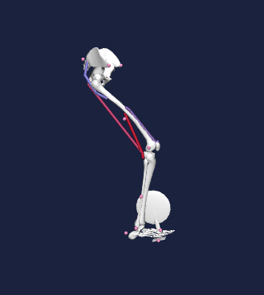

*Figure 3, A CMC Tool -run OpenSim model with all four muscles activated as shown in red.*

Step (5) of the workflow includes comparing the results to cycling kinematics (joint angles), dynamics (pedal forces), and metabolic expenditure to literature (where applicable) and to the results of previous iterations. From this, we will be able to determine the relationship between saddle position and metabolic expenditure. An example of this is seen in Figure 4.

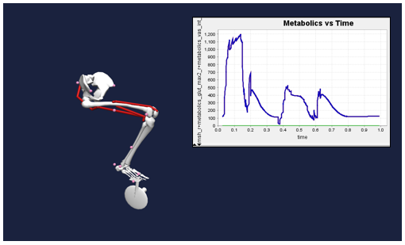

*Figure 4, Metabolic Probe Tool generated from CMC Tool output.*

From this workflow, we have a clear path forward in generating cycling efficiency results based on accompanying kinematics for various saddle positions.

# Plan for the Next 3 Weeks

Given the proposed workflow, the coming weeks will include an abundance of testing via parameterization of model features, specifically: saddle position, number of muscles included in the model, and generation mode for the external forces applied at the pedal. Using these variables as inputs to our existing model, we aim to test a large range of values and generate body kinematics, muscles states, and metabolics, reflective of the model feature changes. With each parameterized change, we will be able to compare our outputs to prior trials and improve the biomechanical complexity of our model over time. Each of the model features (saddle position, number of muscles, type of external force generation), will be parameterized in parallel. This will allow us to maximize parameterization while still only varying one variable at a time.

For the saddle position parameterization, we look to adjust the geometry of the OpenSim model. This will allow us to address the original problem definition posed by Specialized. To do this, we can begin by varying the position of the pelvis of our OpenSim model through a range of values. This will effectively change the hip angle of the musculoskeletal model. Changing seat position will propagate the remaining joint angle changes (knee, ankle) through the rest of the skeleton with simple kinematic constraints. This can be done manually through OpenSim’s geometry files by adjusting the fixed position of the pelvis for each parameterized change, but we are hoping to automate it through a script in MATLAB that will create several geometry files of the exact same content except at the x, y positions for the pelvis.

For muscle parameterization, we are looking to see how additional muscles can impact the muscle states while maintaining kinematic integrity of the pedaling motion. We will aim to add subsequent lower limb muscles like the gastrocnemius, tibialis anterior, and soleus, which are currently not included in the existing model. This parameterization of increasing the number of lower limb muscles incorporated will allow us to iteratively improve the biomechanical complexity of our model. The implementation will require selecting and inserting new muscles into the model’s geometry files. We can do this by specifying the location of the muscle origin and insertion points and various muscle properties for each new muscle we add.

Finally, we look to parameterize external forces by increasing the realism of such forces. Currently, we can extract constraint forces from the pedal onto the foot from running the Forward Dynamics Tool in OpenSim with a nonuniform cadence. Yet these forces have room for improvement when compared to literature. To create more realistic reaction forces, we will need to develop a tool to efficiently generate force data, and we are considering two methodologies for this.

The first methodology requires a MATLAB script to calculate ground reaction forces from joint trajectories and essentially automates a dynamics solver for a parameterized input of joint angles.

The second methodology imposes a strict cadence over the motion and uses the improved constraint forces from a Forward Dynamics Tool as force output. We can do this by using joint angle data from OpenSim and imposing an even cadence through MATLAB.

Both methodologies are promising in terms of producing external ground reaction forces, which are more realistic than the constraint forces that we are using currently. Which path we ultimately use will depend on timing, resources, implementation complexity, and most importantly, result accuracy compared to literature of ground reaction pedal forces.

Looking forward to the next weeks, the most immediate tasks will include the tool development for automation of model feature parameterizations (saddle position, external forces). After creating the tools, it will be a matter of following our workflow steps of 1) Adjusting model parameters, 2) running the model for kinematics, 3) adjusting model specific CMC codes, 4) running the CMC Tool for muscle excitations and metabolic probes, and 5) comparing results to previous iterations of model input parameterizations.

# References

[1] Tucker, J. Personal E-mail Correspondence. 13 January 2020.

[2] Faulkner, S. and Jobling, P. *The Effect of Upper-Body Positioning on the Aerodynamic-Physiological Economy of Time-Trial Cycling.* International Journal of Sports Physiology and Performance, (2020).

[3] Dodge, David. *The Most Efficient Transportation On the Planet*. Huffington Post Online (2013).

[4] Koelewign, A. D. et al. *Metabolic cost calculations of gait using musculoskeletal energy models, a comparison study.* PLOS ONE 14(9): e0222037, (2019).

[5] Dembia CL, Silder A, Uchida TK, Hicks JL, Delp SL *Simulating ideal assistive devices to reduce the metabolic cost of walking with heavy loads.* PLOS ONE 12(7): e0180320, (2017).

[6] Jackson, R. W. and Collins, S. H. *An experimental comparison of the relative benefits of work and torque assistance in ankle exoskeletons*. J Appl Physiol 119: 541–557, (2015).

[7] Leib, D. *The Effects of Clear Placement on Muscle Mechanics and Metabolic Efficiency in Prolonged Sub-Maximal Cycling*. Ball State University Biomechanics Laboratory Thesis, (2008).

[8] Pottinger, M. *Inverse Dynamic Analysis of ACL Reconstructed Knee Joint Biomechanics During Gait and Cycling Using OpenSim*. California Polytechnic State University, San Luis Obispo Thesis, (2018).

[9] Coleman DA, Wiles JD, Davison RC, Smith MF, Swaine IL. *Power output measurement during treadmill cycling*. Int J Sports Med. ;28(6):525-30, (2007).

[10] Peveler, W. and Green, J. Effects Of Saddle Height On Economy And Anaerobic Power In Well-trained Cyclists. National Strength and Conditioning Association , Vol 25, 3, (2011).

[11] Hull, M.L. and Jorge, M. *A Method For Biomechanical Analysis of Bicycle Pedalling*. Journal of Biomechanics Vol 18 No 9. pp 631-644, (1985).

[12] Gonzalez, H. and Hull, M.L. *Multivariable Optimization of Cycling Biomechanics*. Journal of Biomechanics Vol. 22 No 11/12 pp 1151-1161, (1989).

[13] Uchida TK, Seth A, Pouya S, Dembia CL, Hicks JL, Delp SL (2016) *Simulating Ideal Assistive Devices to Reduce the Metabolic Cost of Running*. PLoS ONE 11

[14] Uchida TK, Hicks JL, Dembia CL, Delp SL (2016) *Stretching Your Energetic Budget: How Tendon Compliance Affects the Metabolic Cost of Running*. PLoS ONE 11

[15] Hamner, Samuel R, Delp, Scott L. *Muscle contributions to fore-aft and vertical body mass center accelerations over a range of running speeds*, Journal of Biomechanics, Volume 46, Issue 4, 2013

[16] Fonda, B., & Sarabon, N. (2010). *Biomechanics of cycling ( Literature review )*. Sport Science Review, 19(1), 187–210

[17] Ferrer-Roca V, Roig A, Galilea P, García-López J. *Influence of saddle height on lower limb kinematics in well-trained cyclists: static vs. dynamic evaluation in bike fitting*. J Strength Cond Res. 2012

[18] Bini RR, Tamborindeguy AC, Mota CB. *Effects of saddle height, pedaling cadence, and workload on joint kinetics and kinematics during cycling*. J Sport Rehabil. 2010

[19] Henrot, C and Jeffries, L. [*OpenSim Teaching Materials -- Educational Cycling Model*](https://simtk-confluence.stanford.edu/display/OpenSim/OpenSim+Teaching+Materials+--+Educational+Cycling+Model). BIOE-ME 485 Spring 2018